**Practical 8: Implementation of Graph**

Name: Sutariya Savankumar

Roll no: MA065

1. **Write a program to implement an undirected graph with the following.**

**➔ Create an adjacency matrix.**

**➔ Create an adjacency List.**

**➔ Print the information of the graph such as number of edges, edges list, degree**

**of each vertex. (using both matrix and list)**

**➔ implement traversal of graph using DFS (using both matrix and list)**

**➔ implement traversal of graph using BFS. (using both matrix and list)**

Code

#include <stdio.h>

#include <stdlib.h>

#define max_vert 50

int adjmat[max_vert][max_vert];

typedef struct node{

    int vertex;

    struct node *next;

} Node;

Node *adjList[max_vert];

int numVertices = 0, numEdges = 0;

void addEdge(int src, int dest){

    adjmat[src][dest] = 1;

    adjmat[dest][src] = 1;

    Node *newNode = (Node *)malloc(sizeof(Node));

    newNode->vertex = dest;

    newNode->next = adjList[src];

    adjList[src] = newNode;

    newNode = (Node *)malloc(sizeof(Node));

    newNode->vertex = src;

    newNode->next = adjList[dest];

    adjList[dest] = newNode;

    numEdges++;

}

void dfsMatrix(int vertex, int visited[]){

    visited[vertex] = 1;

    printf("%d ", vertex);

    for (int i = 0; i < numVertices; i++){

        if (adjmat[vertex][i] && !visited[i]){

            dfsMatrix(i, visited);

        }

    }

}

void dfsList(int vertex, int visited[]){

    visited[vertex] = 1;

    printf("%d ", vertex);

    Node *currNode = adjList[vertex];

    while (currNode != NULL){

        int adjVertex = currNode->vertex;

        if (!visited[adjVertex]){

            dfsList(adjVertex, visited);

        }

        currNode = currNode->next;

    }

}

void bfsMatrix(int startVertex){

    int visited[max_vert] = {0};

    int queue[max_vert];

    int front = -1, rear = -1;

    visited[startVertex] = 1;

    queue[++rear] = startVertex;

    while (front != rear){

        int vertex = queue[++front];

        printf("%d ", vertex);

        for (int i = 0; i < numVertices; i++){

            if (adjmat[vertex][i] && !visited[i]){

                visited[i] = 1;

                queue[++rear] = i;

            }

        }

    }

}

void bfsList(int startVertex){

    int visited[max_vert] = {0};

    int queue[max_vert];

    int front = -1, rear = -1;

    visited[startVertex] = 1;

    queue[++rear] = startVertex;

    while (front != rear){

        int vertex = queue[++front];

        printf("%d ", vertex);

        Node *currNode = adjList[vertex];

        while (currNode != NULL){

            int adjVertex = currNode->vertex;

            if (!visited[adjVertex]){

                visited[adjVertex] = 1;

                queue[++rear] = adjVertex;

            }

            currNode = currNode->next;

        }

    }

}

void printGraph(){

    printf("Number of vertices: %d\n", numVertices);

    printf("Number of edges: %d\n", numEdges);

    printf("Edges list:\n");

    for (int i = 0; i < numVertices; i++){

        Node *currNode = adjList[i];

        while (currNode != NULL){

            if (i < currNode->vertex){

                printf("%d - %d\n", i, currNode->vertex);

            }

            currNode = currNode->next;

        }

    }

    printf("Adjacency Matrix:\n ");

    for (int i = 0; i < numVertices; i++){

        printf("%d ", i);

    }

    printf("\n");

    for (int i = 0; i < numVertices; i++){

        printf("%d: ", i);

        for (int j = 0; j < numVertices; j++){

            printf("%d ", adjmat[i][j]);

        }

        printf("\n");

    }

}

void createGraph(){

    numVertices = 7;

    for (int i = 0; i < numVertices; i++){

        adjList[i] = NULL;

    }

    addEdge(0, 1);

    addEdge(0, 3);

    addEdge(1, 2);

    addEdge(2, 4);

    addEdge(2, 6);

    addEdge(3, 4);

    addEdge(3, 5);

    addEdge(4, 6);

    addEdge(5, 6);

}

int main(){

    createGraph();

    printf("Undirected Graph:\n");

    printf(" DFS using adjacency matrix:\n");

    int visited[max_vert] = {0};

    dfsMatrix(1, visited);

    printf("\n");

    printf("DFS using adjacency list:\n");

    int visitedList[max_vert] = {0};

    dfsList(1, visitedList);

    printf("\n");

    printf("BFS using adjacency matrix:\n");

    bfsMatrix(1);

    printf("\n");

    printf("BFS using adjacency list:\n");

    bfsList(1);

    printf("\n");

    printGraph();

    return 0;

}

Output

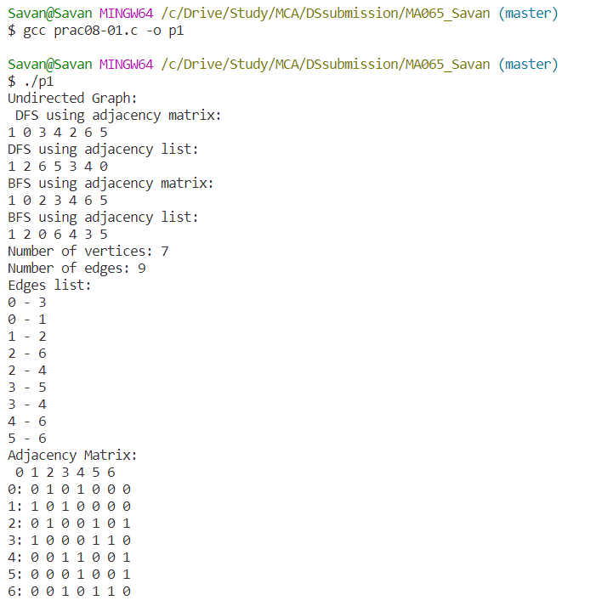

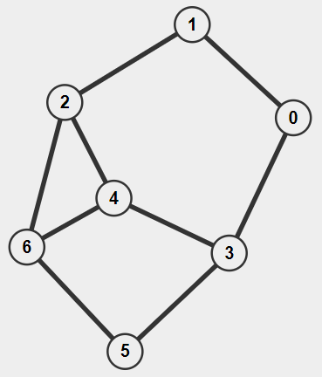

1. **Write a program to implement a directed graph with the following.**

**➔ Create an adjacency matrix.**

**➔ Create an adjacency List.**

**➔ Print the information of the graph such as number of edges, edges list, degree**

**of each vertex. (using both matrix and list)**

**➔ implement traversal of graph using DFS (using both matrix and list)**

**➔ implement traversal of graph using BFS. (using both matrix and list)**Code

#include <stdio.h>

#include <stdlib.h>

#define max 50

int adjmat[max][max];

typedef struct node{

    int vertex;

    struct node *next;

} Node;

Node *adjList[max];

int numVertices = 0, numEdges = 0;

void addEdge(int src, int dest){

    adjmat[src][dest] = 1;

    Node *newNode = (Node *)malloc(sizeof(Node));

    newNode->vertex = dest;

    newNode->next = adjList[src];

    adjList[src] = newNode;

    numEdges++;

}

void dfsMatrix(int vertex, int visited[]){

    visited[vertex] = 1;

    printf("%d ", vertex);

    for (int i = 0; i < numVertices; i++){

        if (adjmat[vertex][i] && !visited[i]){

            dfsMatrix(i, visited);

        }

    }

}

void dfsList(int vertex, int visited[]){

    visited[vertex] = 1;

    printf("%d ", vertex);

    Node *currNode = adjList[vertex];

    while (currNode != NULL){

        int adjVertex = currNode->vertex;

        if (!visited[adjVertex]){

            dfsList(adjVertex, visited);

        }

        currNode = currNode->next;

    }

}

void bfsMatrix(int startVertex){

    int visited[max] = {0};

    int queue[max];

    int front = -1, rear = -1;

    visited[startVertex] = 1;

    queue[++rear] = startVertex;

    while (front != rear){

        int vertex = queue[++front];

        printf("%d ", vertex);

        for (int i = 0; i < numVertices; i++){

            if (adjmat[vertex][i] && !visited[i]){

                visited[i] = 1;

                queue[++rear] = i;

            }

        }

    }

}

void bfsList(int startVertex){

    int visited[max] = {0};

    int queue[max];

    int front = -1, rear = -1;

    visited[startVertex] = 1;

    queue[++rear] = startVertex;

    while (front != rear){

        int vertex = queue[++front];

        printf("%d ", vertex);

        Node *currNode = adjList[vertex];

        while (currNode != NULL){

            int adjVertex = currNode->vertex;

            if (!visited[adjVertex]){

                visited[adjVertex] = 1;

                queue[++rear] = adjVertex;

            }

            currNode = currNode->next;

        }

    }

}

void printGraph(){

    printf("Number of vertices: %d\n",numVertices);

    printf("Number of edges: %d\n",numEdges);

    printf("Edges list:\n");

    for (int i = 0; i < numVertices; i++){

        Node *currNode = adjList[i];

        if(currNode != NULL){

            printf("\n%d: ", currNode->vertex);

            while (currNode != NULL){

                printf("-> %d", i,currNode->vertex);

                currNode = currNode->next;

            }

        }

    }

    printf("Adjacency Matrix:\n ");

    for (int i = 0; i < numVertices; i++){

        printf("%d ", i);

    }

    printf("\n");

    for (int i = 0; i < numVertices; i++){

        printf("%d: ", i);

        for (int j = 0; j < numVertices; j++){

            printf("%d ", adjmat[i][j]);

        }

        printf("\n");

    }

}

void createGraph(){

    numVertices = 7;

    for (int i = 0; i < numVertices; i++){

        adjList[i] = NULL;

    }

    addEdge(0, 1);

    addEdge(0, 3);

    addEdge(1, 2);

    addEdge(2, 4);

    addEdge(2, 6);

    addEdge(3, 4);

    addEdge(3, 5);

    addEdge(4, 6);

    addEdge(5, 6);

}

int main(){

    createGraph();

    printf(" (DFS using adjacency matrix:\n");

    int visited[max] = {0};

    dfsMatrix(1, visited);

    printf("\n");

    printf("DFS using adjacency list:\n");

    int visitedList[max] = {0};

    dfsList(1, visitedList);

    printf("\n");

    printf("BFS using adjacency matrix:\n");

    bfsMatrix(1);

    printf("\n");

    printf("BFS using adjacency list:\n");

    bfsList(1);

    printf("\n");

    printGraph();

    return 0;

}

Output

